Bos'n Cross
- Pyrate Captain
- Member

- 536 posts
- Gender:Male
- Location:Portsmouth
- Interests:many things.......
Posted September 29, 2011 · Report post
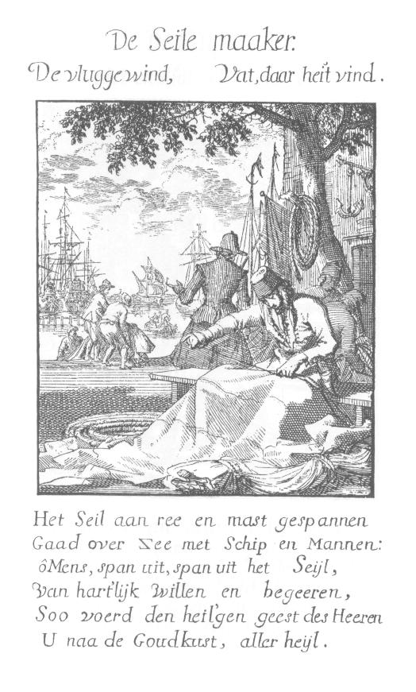
Well, coming across the above (dutch 17th century i believe.....no idea what is says...) image reminded me that i am in need of a sailmakers bench....and tools that accompany it.......does anyone have anything on sail bench ? i can find all the 19th century things in the world.....but not so much on 18th or 17th century..........

Brit.Privateer
- Old Twillian
- Member

- 246 posts
- Gender:Male
- Location:North Carolina
- Interests:Atlantic World Maritime History during the Colonial Era. I specialize in early provincial era (1680-1740) and do quite a bit with pirate history.
Posted September 30, 2011 · Report post
Where did you find this image, and from what part of the seventeenth century is that from?

landlubbersanonymous
- Plunderer
- Member

- 354 posts
- Gender:Not Telling
- Location:California, USA
- Interests:History, arts, collecting, reenacting
Posted September 30, 2011 (edited) · Report post
Mr.Cross - Indeed, it always seems like a sharper trowel is needed to dig up the 17th century stuff.
Brit - Here's links to this and additional images from Spiegel van het Menselyk Bedryf
aka... The Book of Trades by Jan and Caspar Luyken...
http://en.wikipedia....of_Trades%22%29
or...
http://www.geneaknow...ken/luyken.html
Edited October 25, 2011 by landlubbersanonymous

Bos'n Cross
- Pyrate Captain
- Member

- 536 posts
- Gender:Male
- Location:Portsmouth
- Interests:many things.......
Posted October 5, 2011 · Report post
thanks for linking it, there are some great prints in the set!

landlubbersanonymous
- Plunderer
- Member

- 354 posts
- Gender:Not Telling
- Location:California, USA
- Interests:History, arts, collecting, reenacting
Posted November 19, 2011 (edited) · Report post
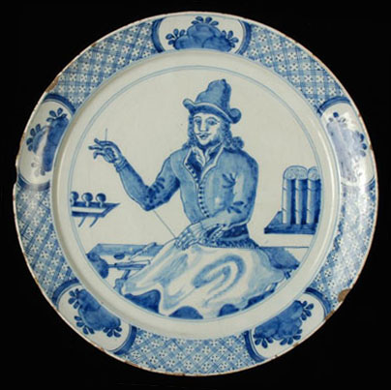
An old Dutch Delft plate from the period showing work on a sail.
Not much detail of the bench. The hunt continues.
Edited November 19, 2011 by landlubbersanonymous

Dutchman
- Has anyone seen my cousin?
- Admin

- 1,773 posts
- Gender:Male
- Location:tidewater virginia
Posted November 19, 2011 · Report post
actually lubber, it gives us a lot to work with. this is a good find!
looking at the legs, they are pegged and splayed out instead of narrow boards. this is typical of a loft bench rather than one found afloat. if the right hand legs are set the same distance as the left, the end of the bench is just out of view. looking at the bench v/s bum ratio, our sailmaker takes up about 1/3 of the bench. so basing the bum on an 18 to 24 inch beam the bench would be 4 1/2 to 6 feet long- about as short as you would want it to be. while there is no cow pen to hold his tools, there is an interesting piece there. obviously the knife, the small round blob seems to be a pin cusion. i have no idea about the thing falling off the corner of the bench. now look at the front of the bench and material. lo and behold we have a taylors third hand! ti's a small clamp used to hold the material onto the bench to keep the material from moving much like a modern sailmakers hook. the shelves on the wall hold fids or fit blades of some sort but i have no idea about the rolls on the right.

landlubbersanonymous
- Plunderer
- Member

- 354 posts
- Gender:Not Telling
- Location:California, USA
- Interests:History, arts, collecting, reenacting
Posted November 19, 2011 · Report post
On 11/19/2011 at 4:48 PM, Dutchman said:
actually lubber, it gives us a lot to work with. this is a good find!
looking at the legs, they are pegged and splayed out instead of narrow boards. ...
Dutch - It's encouraging to know this is useful.

landlubbersanonymous
- Plunderer
- Member

- 354 posts
- Gender:Not Telling
- Location:California, USA
- Interests:History, arts, collecting, reenacting
Posted November 19, 2011 · Report post
Another Dutch artifact from the same period. (Note the date at the base of columns.)
This was a small relief carving from a door. Interestingly, the rolled stuff appears above on the right as well.
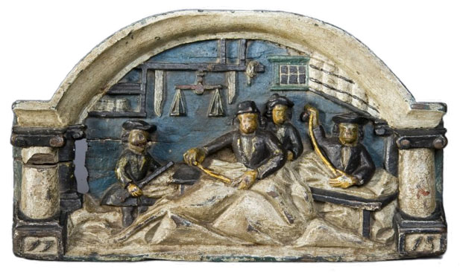

Dutchman
- Has anyone seen my cousin?
- Admin

- 1,773 posts
- Gender:Male
- Location:tidewater virginia
Posted November 19, 2011 · Report post
i would have to guess it was rolls of fabric.

landlubbersanonymous
- Plunderer
- Member

- 354 posts
- Gender:Not Telling
- Location:California, USA
- Interests:History, arts, collecting, reenacting
Posted November 20, 2011 · Report post
On 11/19/2011 at 9:49 PM, Dutchman said:
i would have to guess it was rolls of fabric.
We're inclined to agree as factory rolled toilet paper had yet to be invented.

Fox
- Old Twillian
- Moderator

- 2,564 posts
- Gender:Male
- Location:Beautiful lush Devon, England
- Interests:Nautical history of the 16-18th centuries and living history based thereon.
Shooting pirates.
Posted November 20, 2011 · Report post
Good finds guys :)

Dutchman
- Has anyone seen my cousin?
- Admin

- 1,773 posts
- Gender:Male
- Location:tidewater virginia
Posted November 20, 2011 · Report post
which leads us right into a discussion I had with someone last week. . . . . how was fabric shipped to the colonies? Was it on spindles or folded or some other way? It seems a bit impractical to make it on a roll, undo it, fold it, then ship......... any ideas?

PoD
- Pyrate Captain
- Member

- 696 posts
- Gender:Male
- Location:Warrington UK
- Interests:Pirates, graphic novels, computer art, Listening to music, Going to gigs, Beer and Wine drinking, historical research, Period weaponry and Leatherwork
Posted November 20, 2011 (edited) · Report post
this is some sort of broadsheet from 1794 showing a sailmaker at work

There is also plans on making an 18th century sailmakers bench here:
http://books.google.co.uk/books?id=qyUDAAAAMBAJ&lpg=PA122&dq=sailmakers%20bench&pg=PA121#v=onepage&q&f=false
Edited November 20, 2011 by PoD

landlubbersanonymous
- Plunderer
- Member

- 354 posts
- Gender:Not Telling
- Location:California, USA
- Interests:History, arts, collecting, reenacting
Posted November 22, 2011 · Report post
Foxe & Dutch - If possible, we'd like to get back on an hourly wage. This salaried web search position isn't paying the bills.
PoD - Awesome! Thanks for posting.

Louisiana Jeff
- Deck Swabber
- Member

- 45 posts
- Gender:Male
- Location:Louisiana, USA
- Interests:Honest merchant sailor looking for fortune.
Posted November 22, 2011 · Report post
Do these benches have storage under the seat? Like a piano bench? The pic of the plate seems ( t' me untrained eye) seems to have space where the leg connects to the top.

Korisios
- Pyrate Captain
- Member

- 565 posts
- Gender:Male
- Location:Netherlands
- Interests:Celts BC, Guatemala, Pirats
Posted November 25, 2011 · Report post
On 9/29/2011 at 3:01 PM, Bos said:
Well let me see if i can translate it...:
The Sail, stretched on ra and mast.
Go's over see with Ship and Man:
So Men do stretch do stretch your sail,
of affectionate will and desire,
So quids Gods Holy Spirit
you to the gold coast, of all salvation...

landlubbersanonymous
- Plunderer
- Member

- 354 posts
- Gender:Not Telling
- Location:California, USA
- Interests:History, arts, collecting, reenacting
Posted November 25, 2011 · Report post
Louisiana J - So far, the only ones I've seen with lower storage have been the later, 19th & 20th century ones.
Korisios - "quids"??

Korisios
- Pyrate Captain
- Member

- 565 posts
- Gender:Male
- Location:Netherlands
- Interests:Celts BC, Guatemala, Pirats
Posted November 25, 2011 · Report post
Sorry:
guides...

Bos'n Cross
- Pyrate Captain
- Member

- 536 posts
- Gender:Male
- Location:Portsmouth
- Interests:many things.......
Posted November 25, 2011 · Report post
oh this is like friggin candy now....so.....we have found now that the bench hook can be replaced with a clamp....and overall tool trays and slots dont seem to have been put on benches yet.......i have also found that sailmakers palms are not the same in the 17th century as the ones you see in the later 18th and 19th. if you look at my original image youll see that the palm only goes around the middle section of the hand.....doesnt go around the thumb at all....an example can be found at the chatham dockyard, off of the invincible 1758......but i cant yet find a gggooood picture...if anyone lives near by.....*cough*......as for the bundle like tubes in the image backgrounds, i am very sure are rolls of canvas with were shipped in rolls (o know #4 canvas was 25 inches wide and in rolls like that....thanks cj!).......im working on getting the info about canvas weight and all down right now, hopefully ill be able to flesh this out a bit........thank you so much landlubbersanonymous ....your plate, may have just made me a bench!

Bos'n Cross
- Pyrate Captain
- Member

- 536 posts
- Gender:Male
- Location:Portsmouth
- Interests:many things.......
Posted November 25, 2011 · Report post
here is a question for landlubber......do you have any info on that plate?.....someone more experienced than myself, has a feeling that it mmmiiiggghhhhht be a tailor.....and just wants to be sure......

Fox
- Old Twillian
- Moderator

- 2,564 posts
- Gender:Male
- Location:Beautiful lush Devon, England
- Interests:Nautical history of the 16-18th centuries and living history based thereon.
Shooting pirates.
Posted November 25, 2011 · Report post
The awls in the tool-shelf in the background are more suggestive of a sailmaker than a tailor to my mind

Dutchman
- Has anyone seen my cousin?
- Admin

- 1,773 posts
- Gender:Male
- Location:tidewater virginia
Posted November 25, 2011 · Report post
im going with sailmaker too. the bench is a specific tool. tailors are normaly depicted with tabletops and patterns.
cross, i still have the planks for your bench and the pattern off mine. just let me know when......

landlubbersanonymous
- Plunderer
- Member

- 354 posts
- Gender:Not Telling
- Location:California, USA
- Interests:History, arts, collecting, reenacting
Posted November 27, 2011 · Report post
On 11/25/2011 at 2:26 PM, Bos said:
here is a question for landlubber......do you have any info on that plate?.....someone more experienced than myself, has a feeling that it mmmiiiggghhhhht be a tailor.....and just wants to be sure......
Only that the piece is part of the collection at the Rotterdam Museum.

Bos'n Cross
- Pyrate Captain
- Member

- 536 posts
- Gender:Male
- Location:Portsmouth
- Interests:many things.......
Posted November 30, 2011 · Report post
thanks landlubber........and thanks for you input fox, and dutch, i know a guy who does a really good sailmakers impression, and though he also thinks it is more than likely that it is a sailmaker, he just wanted to be sure.....hes helping me out on research etc......dutch, not exactly sure how i want teh bench as for yet....im positive id like it to be rather simple though, ill speak with you on the matter this weekend...id like to have something doable in time for mta.....(i still have that sail you started).......

landlubbersanonymous
- Plunderer
- Member

- 354 posts
- Gender:Not Telling
- Location:California, USA
- Interests:History, arts, collecting, reenacting
Posted December 1, 2011 · Report post
Bos'n - You're welcome. Glad to be of some assistance. Ditto regard input from others too. I enjoy the challenge of the hunt. This seems to be an important item that crews should consider having for their inventory.

